Trafford School Nurse Team
Tel: 0161 912 3395
Email: TraffordScreeningTeam@mft.nhs.uk
September 2026

Dear Parent/Carer

Welcome to the School Health Service for primary schools

This letter explains the services we offer to support your child in primary school. Every school in Trafford has access to our team. We offer health and wellbeing advice and support for your child. We work closely with children, parents, carers, teachers and other professionals.

We have two teams:
- School nurses – qualified nurses, with additional training in public health.
- Trafford Healthy Schools – this team provides screening, as well as wellbeing and emotional support (not medical advice).

The services we offer children in primary school are:

- The National Child Measurement Programme (reception and year 6) – Our Trafford Healthy Schools team measure the height and weight of all reception and year 6 children. Results are confidential and not shared with school staff or other children. You don’t need to give permission, but you can opt-out if you wish.

- Hearing and vision screening (reception) – Provided by our Trafford Healthy Schools screening team, it is quick and simple. It helps us to identify any early signs of hearing or vision difficulties that may affect your child’s development or learning.
If your child has a medical condition that affects their vision or hearing or has a Programmable Ventriculo-Peritoneal Shunt (PVP Shunt), please let us know.

- General health and wellbeing - If you have any health concerns about your child that may be affecting them in school, please contact a member of the School Nurse Team. We can support you with lots of issues such as sleep, healthy weight management, toileting, emotional health and wellbeing. Drop-in sessions for parents are offered in all primary schools.

To opt out of the screening or measurement programme, please let the team know by email TraffordScreeningTeam@mft.nhs.uk or calling 0161 912 3395.

We use Padlet, a website that works a bit like a notice board. We upload lots of additional information and resources to our Padlet, scan the QR codes below to find out more about children aged 5-11 and families, Family Help and SEND.

Please do not hesitate to contact the team if you have any questions about your child’s health on their journey through primary school. Tel: 0161 912 3395 or email: TraffordScreeningTeam@mft.nhs.uk

Yours sincerely,

Trafford School Health Service

Scan the QR codes below to access more information…

Visit the Trafford School Nurses website | 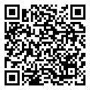
Access the Padlet webpage with information about children aged 5-11 years and families | 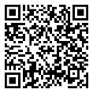
Access the Padlet webpage with information about Trafford Family Help | 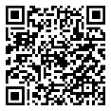
Access the Padlet webpage with information about Special Educational Needs and Disability (SEND) | 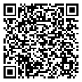

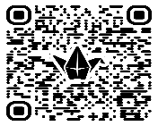
Access the Padlet webpage with information about TLCO’
Children’s Community Nursing (CCN) and Children’s
Learning Disability Nursing Team (CLDN)

