15/01/26
Dear Parents/Carers,

I recently wrote to you to share how we had been able to secure a grant linked with Trafford housing to create further opportunities for families on the Broomwood.

This includes:

- Broomwood Forest school for toddlers, which is held every Wednesday from 9.15-10.00. This is free.
- Broomwood Babies group, which is held at the school every Wednesday from 10.00.10.45. This is free so please come along or pass the details onto families you know.
- We also have a family navigator that is based at the school every Thursday afternoon. She can sign post you to many different services and offer help with any difficulties you might be having. Please call the school if you would like to come in and see her.

I am now able to share a new opportunity with you. The counselling and Family centre are going to be running a ‘Starting Strong’ programme for our families. This is a fully funded 6 week course for parents and carers of children aged 5-16 attending Trafford schools, who are presenting with special educational needs.

The course will be held at Blusci Community Centre (Broomwood Coummunity Centre) and will run from 9.30-11.30 on the following dates:13/3, 20/3, 27/3 |(term break)| 24/4, 1/5, 8/5.

We feel that this is a great opportunity for parents who are worried about their child and how to support them in the best way.
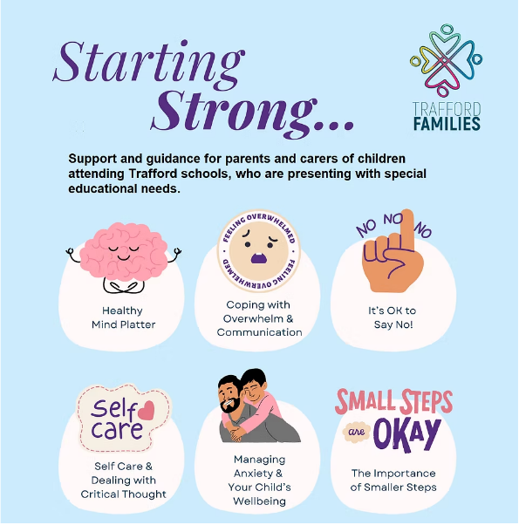
Please call the school office to secure a place on this FREE course.

Many thanks

Dr. Louise Owen

