
Broomwood Primary School
Drop off, collection and uncollected from school policy

POLICY STATEMENT
Definitions: For the purposes of this Policy and procedures a child, young person, pupil or student is referred to as a ‘child’ or a ‘pupil’ and they are normally under 18 years of age. Wherever the term ‘parent’ is used this includes any person with parental authority over the child concerned e.g. carers, legal guardians etc.
Introduction
In order to safeguard our pupils at Broomwood Primary School, it is essential that the school ensures all children arrive at, and leave school at the end of the day with a safe adult. We appreciate that for many families, arrangements need to be flexible and it may be that a few people care for the child after school. Sometimes there will be ‘one-off’ arrangements. For this reason, we have set out clear procedures which all staff and parents/carers must adhere to.
Drop off arrangements
- The main school playground gate opens each day at 8.30.
- Children from reception to year 6 will enter via this gate and line up in a dedicated space with the rest of their class.
- Parents are asked not to remain on the playground, but it is accepted, within reception and year 1, that parents may stay until the children are collected by the class teacher. Within the summer term, to support transition, we ask all parents to leave their children.
- Staff from Broomwood, in high visibility jackets, will be out in the playground to supervise from 8.30. A senior leader will always be present.
- Children are collected from the playground by their class teacher by 8.40 in readiness for the start of the school day at 8.45.
- We expect children from nursery to year 4 to be dropped off by an adult and we will challenge this where we see that it is not happening. We know that some parents allow their children within year 5 and year 6 to make their way to school independently.
- The gate remains open until 9.00. Any child arriving after this time must come to the main school reception and sign in giving a reason for being late.
- Nursery children come in via the main school reception area where they are collected by a member of staff. Nursery children come in at 8.30, the start of their school day. Children who attend nursery in the afternoon are collected from the main school reception area by a member of staff at 12.30.
- Children who attend pre-school in the morning are dropped off at the pre-school entrance by 8.30, the start of their school day. Children who attend in the afternoon are dropped off at 12.30 at the pre-school entrance.
- Children who come to breakfast club are supervised by a member of staff to make their way to their classroom by 8.45.
Early Drop Offs
At Broomwood, we have some pupils who find the playground overwhelming in the morning and therefore we provide a nurture group for them to support in mitigating their anxieties about coming to school. It has been agreed with parents when this intervention has been put into place and specific parents know to drop their children off at the school main reception at 8.30 where they will be collected by the staff member leading the group.
There are a few individuals who have a separate timetable to support more extreme anxiety and a time has been agreed with parents when to drop that child off. This may be slightly later than the rest of the school. Such children will come in through the main school reception and will be met by a designated member of staff.
To support in implementing our graduated approach to reading and maths, we provide early morning interventions that start before the school day. These interventions start at 8.15 and 8.30 and some children are taught in groups and others on an individual basis. Parents know if their child has been selected for such intervention. A member of staff registers the children as they enter the building.
Children who come to breakfast club can be dropped off anytime between 7.45 and 8.15. A member of staff waits at the main school entrance door and registers them as they enter the building. These children then go to their classrooms from 8.30.
Picking up arrangements
- The school day finishes for children from reception to year 6 at 3.15.
- At the start of each year, parents are sent out an electronic form (appendix 1) to complete where they can list the names of safe adults that can collect. This can be amended by calling or emailing the school office. Parents are aware that if an adult arrives to collect a child and they are not on the list, the child will not be able to leave the school. However, we recognise that there are ‘one off’ occasions where another adult may need to pick up. In such circumstances, the parent would need to call the school before 2.45 and send a text confirmation for us to agree to this. This is particularly vital for pupils who are in year 5 and 6 where the class teacher will be used to them walking home by themselves. A member of the office staff will then pass this message onto the class teacher. If however the class teacher is unsure at any point, they will not allow the child to go until they have checked with the office. In year transfers are given a hard copy of the form to complete.
- Children from year 1 to year 6 are collected from the main school playground at 3.15. The gate opens at 3.05. The children line up with their class teacher, who will wear a high visibility jacket, and they are allowed to go when their parent is seen.
- Parents need to ensure that they keep their child with them after they have been handed over. Children must not go on scooters or bikes within the playground and they must not go onto the school field or in the imagination garden.
- The caretaker and a senior leader, in high visibility jackets, are on the school gate to ensure that children leave the playground safely.
- Children from reception are collected from the KS1 playground. Children are released by the class teacher when their parent is seen. They exit the school grounds via the staff carpark. A member of staff, in a high visibility jacket, will be present to ensure that this is done safely. There will be cones to direct you the way that we would like you to walk safely across the car park. Children must not travel on their scooters or bikes across the carpark. Children must not go on any equipment as they pass through the playground.
- Children from nursery who are in part time are collected at 11.30 from the main school reception area where a handover can take place. Children from nursery, who are in all day or who are afternoon part time pupils, are collected from the nursery playground from 3.30. Children are released by the class teacher when their parent is seen. They exit the school grounds via the staff carpark. A member of staff, in a high visibility jacket, will be present to ensure that this is done safely.
- Morning pre-school children are collected from the pre-school classroom at 11.30 and afternoon children are collected from their classroom from 3.30 where a proper handover can take place.
Supply teachers
- A supply teacher will always be supported by a staff member to ensure that the children are released safely.
Children Travelling Home Independently
“There is no law prohibiting children from being out on their own at any age. It is a matter of judgement for parents to decide when children can play out on their own, walk to the shops or school”. (Is it legal? A parent’s guide to the law by the Family and Parenting Institute -June 2011).
The NSPCC advise the following:
- Children under 8 should not be outdoors for a considerable length of time unaccompanied
- Children under the age of 12 should not be home alone for more than a very short period of time.
Our procedures:
- Only children in Year 5 and year 6 are allowed to leave school independently to walk home provided parental consent has been given in writing. We ask parents to complete an electronic form (appendix 2). Parents are asked to send us an email if they want to change this. The school keeps a register of children who have permission to travel to and from school independently which is shared with the child’s class teacher. Children must notify the class teacher when leaving school. The children will always be encouraged to walk home together in pairs. In an extenuating circumstances or if an alternative method of transport (e.g. buses/ taxis) are required for children in Year 6 or Year 5 to travel home in independently, then a request must be made in writing to the Headteacher. If approved a signed parental consent form will be kept on record. If a child should not arrive home at the expected time the parent/carer is expected to notify the school immediately. These permissions only apply to children leaving school at the end of the school day: any child leaving school early (e.g. for medical reasons) must be collected by a responsible adult.
- We use the above permission for children in year 5 and year 6 travelling independently after an extra-curricular club. However if there is an after school event, such as a disco, we ask that parents inform us by text if they want their child to walk home independently. We do however encourage that all children are collected by an adult.

Early Collection Procedures
- Whenever pupils need to be collected before their formal dismissal time, parents/carers must provide prior notification by writing or by telephoning the school. This is to ensure that the class teacher is notified and therefore has sufficient time to distribute any homework/notices. At the time of early collection, parents/carers must report to the school office. Parents/carers are required to sign the child out with the time that the child is being collected.
- Office staff will notify teachers that the parent/carer has arrived to collect the pupil. Parents/carers are kindly requested to wait in the office area for their child to arrive from the class. The School recognises that at certain times, pupils may need to attend appointments (including medical appointments) during the school day. The school would always encourage, that wherever possible, appointments are made outside the school day to avoid disruption of your child’s learning. We do however, appreciate some appointments are beyond your control so unavoidable. The school requires evidence for this. In such cases, parents/carers are welcome to collect their child for the appointment and then return them to school during the school day. Parents are required to sign their child out of school. The office will ensure that the child is signed out of school when leaving the premises. When parents return their child to school, they must report the child’s return to the school office so that the school is aware that the child has returned and is back on the school premises. The office will ensure the child is signed back into school upon their return.
Late pick ups
Some children go to our after school club. This has been agreed with the office and parents prior to this happening. Parents pick the children up via the main school entrance and they will phone after school club when they have arrived. Parents pick up anytime between 3.30 and 5.30.
Each term, we provide extracurricular activities. Children have to sign up to these in advance and each staff member leading the club will have a register. Parents collect the children from the school junior playground which is opened by the caretaker. He stands at the gate as the children are dismissed. Most clubs finish at 4.15 with a couple finishing at 4.30.
During the spring term, children within year 6 are invited to stay after school for some extra support for SATs. Parents are informed of this and designated teachers know which children they will be working with. This intervention goes on until 4.15 and the children get picked up from the playground unless they have been permission to walk home by themselves.
Parental Responsibility
The school acknowledges that those with Parental Responsibility have a legal right to collect their children from school which will be respected by the school. In the event of any dispute, it is the responsibility of the parents to notify the school of the arrangements that have been made. The school will of course comply with any court orders that may be in place or if there is a particular request from social care or the police in the short term. There may be occasions where, if the dispute is difficult, that we ask both parents to attend school for pick up and then an agreement is made on site. It is important to note that with any dispute, the school cannot appear to take any sides.
Late/ no collection procedure
Procedure:
In the event of child not being collected on time the school will follow the procedure below:
1. Contact the parent/carer
After the rest of the children have been dismissed the class teacher will bring the child to the main office and the parent/carer will be contacted. If we are unable to contact the parent/carer we will use the alternative numbers on the registration form. The child will remain in the main entrance with a member of staff they are familiar with and the office staff.
2. Recording Information
When a situation of an uncollected child occurs we will record it on CPOMs
We will record the times that the parent/carer was called and the time the child was picked up. Parents who are persistently late will be spoken to or sent a letter from the Head Teacher reminding them of the policy and possible future referral to Social Services.
3. Liaise with Social Services
If we are unable to contact any person on the child’s registration form we will wait with the child, in a safe environment. We will continue to call the numbers on the form until we get a response. As a school we are prepared to wait with the child for about an hour (discretion will be used) and calling social services will be our last resort. We will liaise with social care about the child from 4.15.
4. Going round to the property
If a child hasn’t been collected by 5.00, two members of staff may visit the child’s home address to see if they get a response. This would be reported back to social care.
5. Liaising with social care/police
If the school has exhausted all avenues and a child still hasn’t been collected by 5.15, further liaison will happen with social care but the police will also be informed. The school will work with the other agencies to make the right decision for the pupil in question.
4. Informing Parents/Carers
Discussions will follow with parents/carers about why their child was uncollected. This may lead to a social care referral or support may be offered to the family if deemed appropriate. This support may include things like being linked to Trafford Teams Together or support with offering a place at breakfast club.

Updated: April 2024
Approved: Through Governor hub- April 2024
Reviewed: Louise Owen

Appendix 1
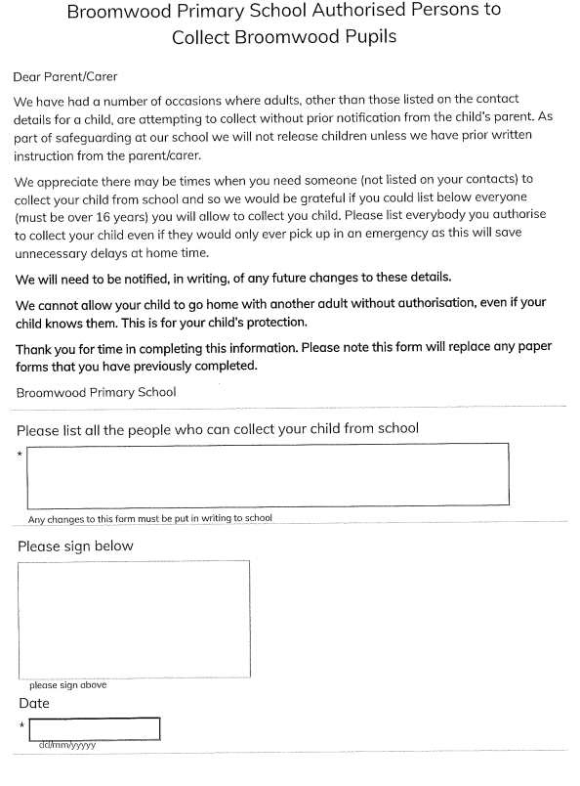

Appendix 2


