Broomwood Primary School
History Policy
Our Vision: Together we believe, together we achieve
Our Mission: To create a positive, enjoyable atmosphere to inspire all to learn and grow
Rationale

At Broomwood Primary School we provide a high-quality, enquiry-based history education which will help pupils gain a coherent knowledge and understanding of Britain’s past and that of the wider world. We believe it is important that our children develop a strong set of values and principles, and that they question and understand what it means to grow up in British society. Teaching History equips pupils to ask questions, think critically, weigh evidence, sift arguments, develop perspective, and make informed judgements. It also helps pupils understand the complexity of people’s lives, the process of change and the diversity of societies and relationships between different groups. It will also develop children’s understanding of their own identity and allow them to think about the challenges of their own time. History at Broomwood is underpinned by four 'Golden Threads': Society, Religion, Economic Activity and Empire. These threads weave through our history curriculum where appropriate and relevant.

In our history lessons, we aim for our children to see their connection to the past and to understand the world today. History makes a significant contribution to an understanding of human rights, to political education, multicultural and religious education, economic awareness, and environmental education. We support our pupils to develop a deeply embedded appreciation of the values of Broomwood Primary and Fundamental British Values. All children should be presented with the opportunity to experience success and enjoyment in history, regardless of race, religion, ethnicity, gender, ability, or disability.

Each unit in our overview is underpinned by rich, substantive knowledge and ambitious, sophisticated, subject-specific vocabulary, whilst also ensuring children are developing their disciplinary knowledge. Each unit of work is planned carefully to ensure concepts are taught in optimal order to support children's understanding and ability to make connections. As well as developing a breadth of historical knowledge, we want our children to become historians. Each unit of work has an emphasis on historical enquiry where children investigate historically framed questions whilst also developing historical enquiries of their own. Key historical concepts sit at the core of our curriculum to ensure the defining characteristics of the subject are ever-present.

At Broomwood the golden threads support with progression in learning and teachers support children in developing connections and developing learning by making reference to each of these threads. As the National Curriculum doesn’t specify specific age groups, History at Broomwood is taught over a two-year rolling programme and key stages work on the same topic areas. An advantage of a two-year cycle is that children learn some age-related expectations in one year and then secure their learning in the following year – an opportunity to reinforce, to provide for even greater ‘mastery’ of the learning; and an opportunity to go deeper with the learning, to use and apply their learning in more situations. This also ensures that Broomwood is able to maintain a sustainable curriculum due to pupil numbers within the school fluctuating at various points. Additionally, it supports teachers in working collaboratively together as a team to discuss the best ways to approach the teaching of learning particular concepts.

In Summary, History at Broomwood:

- Contributes to the personal and social development of pupils.
- Provides an understanding of the present and future with reference to the past, enabling students to develop a sense of time.
- Provides an insight into the cultural heritage of the local, national, and international community.
- Facilitates pupils to develop an understanding of their own cultural roots and shared inheritances.
- Helps pupils to make sense of the outside world.
- Provides an opportunity for seeing, doing, enquiring and experiencing.

Our Aims:
- We will provide a high-quality history education which will help pupils gain a coherent knowledge and understanding of Britain’s past and that of the wider world.
- It will inspire pupils’ curiosity to know more about the past.
- Teaching will equip pupils to ask questions, think critically, handle evidence, sift arguments, develop perspective and judgement.
- History teaching will help pupils understand the complexity of people’s lives, the process of change and continuity, the diversity of societies and relationships between different groups.
- It will also develop children’s’ understanding of their own identity and allow them to think about the challenges of their own time.

As a staff, we agree that History is good when:
- Artefacts, trips, visitors and resources bring it to life
- It is relevant to pupils and they understand their place in history
- Children ask their own questions
- It is hands-on, practical and exploratory
- It starts with open-ended enquiry questions
- Children are handling evidence by inferring from pictures and artefacts
- When children can make links and find similarities and differences within different times/ periods/ places/ civilisations in History
- When children are looking at historical impact and significance– so what?
- There is clear progression of skills within a particular topic (discussed in staff meeting February 2024.)
- Teamwork is involved
- It starts with the children – they raise questions, take control of enquiries and make their own interpretations and discoveries through first-hand experiences
- Children know how to use Historical vocabulary and their explanations are clear
- Children have a chronological awareness

Statutory Requirements:
The National and Early Years Foundation Stage Curriculum provide the frameworks within which we aim to deliver History at appropriate levels.

Foundation Stage
We teach history in EYFS as an integral part of the topic work covered during the year. History knowledge, understanding and skill development in EYFS is taught under the ‘Understanding the World’ Section of Development Matters. History is taught using stories as well as exploring and playing in purposeful, considered areas of provision, through active learning and through creating and thinking critically. There is appropriate progression of learning for history through pre-school, nursery to reception. Children within reception are exposed to the history threads in preparation for the transition to Key Stage One. Across the whole EYFS, History is taught every half term and is lead via an enquiry based question.

Key Stage One
In Key Stage One children will develop an awareness of the past, using common words and phrases relating to the passing of time. They will know where the people and events they study fit within a chronological framework and identify similarities and differences between ways of life in different periods. They will use a wide vocabulary of everyday historical terms. They will ask and answer questions, choosing and using parts of stories and other sources to show that they know and understand key features of events. They will understand some of the ways in which we find out about the past and identify different ways in which it is represented.

Children will be taught about:
- Changes within living memory. Where appropriate, these should be used to reveal aspects of change in national life.
- Events beyond living memory that are significant nationally or globally.
- The lives of significant individuals in the past who have contributed to national and international achievements. Some should be used to compare aspects of life in different periods.
- Significant historical events, people and places in their own locality.

Children are taught the above through the following topic areas:

Year A | Year B
Childhood then and Now (Toys and games through the decades and how childhood has changed) | Who did it? (Looking at the police and how the police force started)
Fire Fire (Great Fire of London) | Investigating India (Mahatma Ghandi- Early understanding of British Empire and Indian independence).
Circle of Life (Mary Anning) | Superheroes (Florence Nightingale, Mary Seacole, Neil Armstrong, Rosa Parks and Emiline Pankhurst)
What makes this place special (Changes in houses and homes) | The Seaside (Why the seaside was important to Victorians and create a comparison to today, differences between childhood then and now)

Key Stage Two
In Key Stage Two children will continue to develop a chronologically secure knowledge and understanding of British, local and world history, establishing clear narratives within and across the periods they study. They will note connections, contrasts and trends over time and develop the appropriate use of historical terms. They will regularly address and sometimes devise historically valid questions about change, cause, similarity and difference, and significance. They will construct informed responses that involve thoughtful selection and organisation of relevant historical information. They will understand how our knowledge of the past is constructed from a range of sources.

Children will be taught about:
- Changes in Britain from the Stone Age to the Iron Age
- The Roman Empire and its impact on Britain
- Britain’s settlement by Anglo-Saxons and Scots
- the Viking and Anglo-Saxon struggle for the Kingdom of England to the time of Edward the Confessor
- a local history study
- The Windrush generation
- The British Empire
- a study of an aspect or theme in British history that extends pupils’ chronological knowledge beyond 1066
- the achievements of the earliest civilizations – an overview of where and when the first civilizations appeared and a depth study of Ancient Egypt
- Ancient Greece – a study of Greek life and achievements and their influence on the western world
- a non-European society that provides contrasts with British history – Benin (West Africa) c. AD 900-1300.

At Broomwood, we believe a certain level of maturity must be reached for children to fully appreciate the complexities of certain historical periods and events. For example, the Ancient Greeks is studied in upper key stage two instead of lower key stage two. This ensures that learning is more appropriate and meaningful to children when being taught the complexities of themes such as democracy.

Equal Opportunities
All children should be presented with the opportunity to experience success, regardless of race, ethnicity, gender, ability or disability. See the Equal Opportunities Policy. We ensure that equity exists within our History curriculum and that we implement some adaptive teaching methods to ensure that all pupils can access the same learning objective. Examples of adaptive teaching includes: QR codes, collaborative groupings, Reading pens etc…

Broomwood Primary School is keen to make sure that we do not make it difficult for disabled children, young people and adults to be involved in every part of school life. We have a legal duty not to discriminate against disabled people and to monitor how many of our pupils. Staff, parents/carers and governors are disabled under the Disability Discrimination Act 2005.

Broomwood Primary School recognises that disabled people are very diverse and include people with a physical impairment, visual impairment, hearing impairment, learning difficulty, specific learning difficulty (e.g. dyslexia), mental health issues, people who are deaf, British sign language users and people with long term health conditions.

E- Safety
When any aspect of ICT is used, the school’s E safety policy will be followed. Children have the understanding that there is an expectation of them to use technology appropriately when carrying out any form of research. Within school we use smooth wall to monitor what children are accessing at any point. This supports in keeping children safe.

Planning
Teachers will plan suitably challenging activities that will meet the statutory requirements of the National Curriculum and Understanding the World for the EYFS curriculum. Planning is reviewed prior to every new topic being taught. This is to ensure that cohort considerations are included in how the topic is taught and that learning from it previously being taught is taken into consideration.

Long Term Planning
The teachers follow the History Whole School Overview which ensures reasonable breadth and balance across the age range. Teachers are aware of the historical topics to be covered by their class for the year ahead. There is a two-year running program based on a thematic approach, where the topics are carefully selected to give the children opportunities to explore historical topics as well as experience historical skills and forms of enquiry. History is taught via progressive enquiry based questions which have been determined by the subject leader.

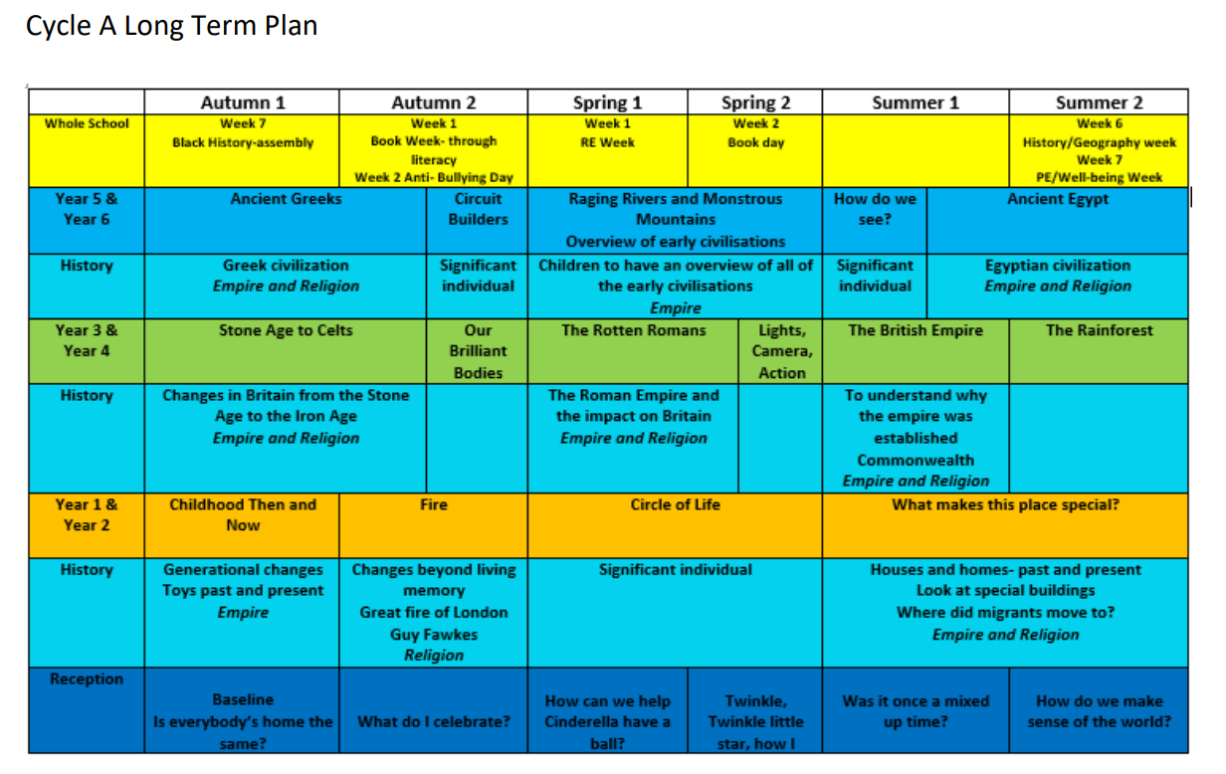

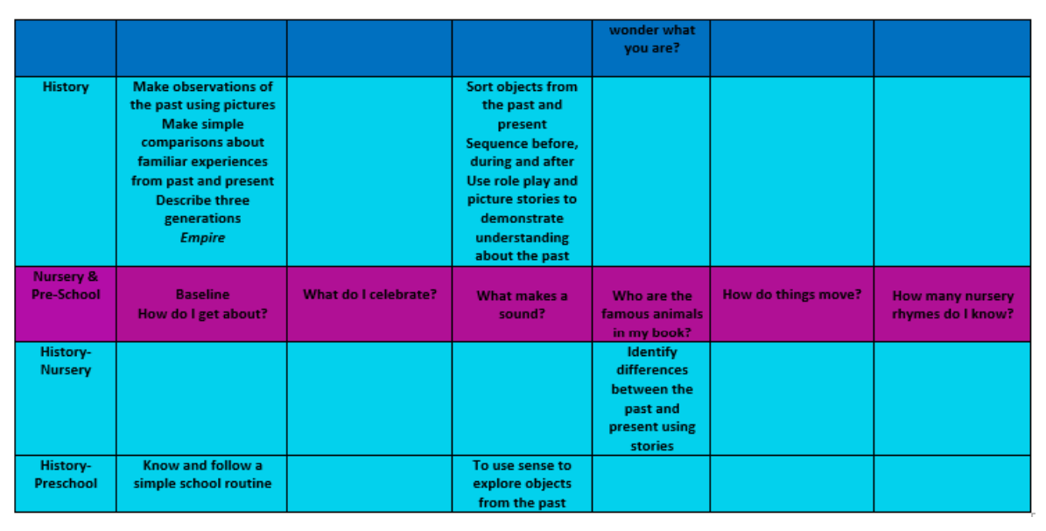

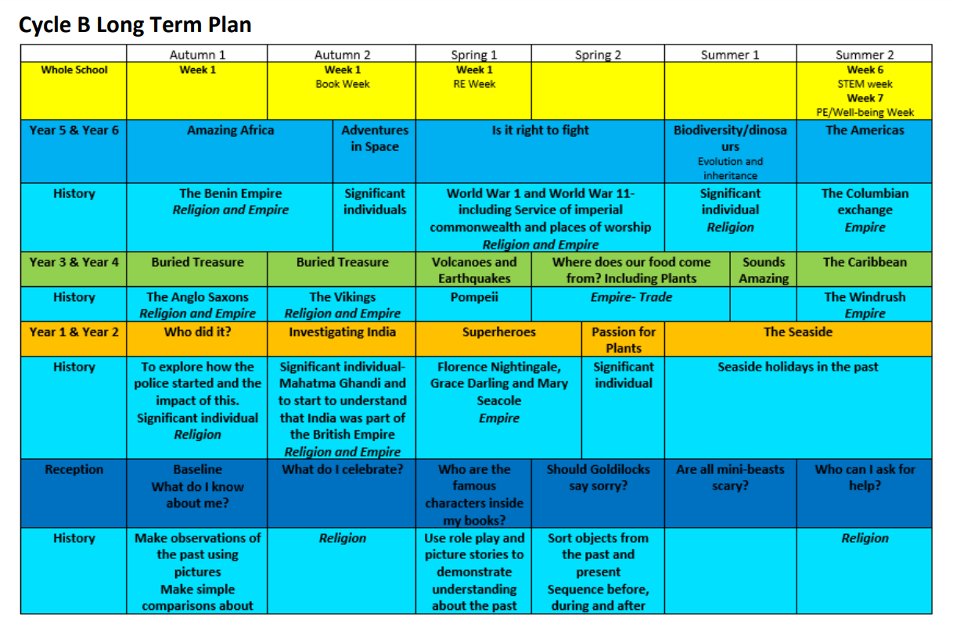

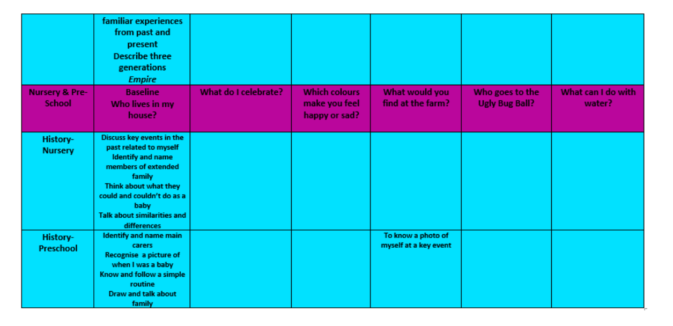

Medium Term Planning
Medium term planning is detailed and highlights the specific substantive knowledge that needs to be covered linked to each enquiry-based question. Planning is discussed within a key stage so that adaptations should be made- As it not an ‘off the shelf’ scheme, history, whilst covering the substantive knowledge can be implemented differently and teachers use their professional judgement to consider what is needed across the key stage.
This planning includes:
- The enquiry-based question and the substantive knowledge that is going be taught. It emphasises the golden threads that will be covered.
- Key vocabulary- both disciplinary and vocabulary linked to the specific topic area.
- Resources
- Learning Activities and how it is adaptive for all pupils.
- Assessment (Kahoot/ end of topic assessment)

Short Term Planning
Teachers should plan the week ahead in some detail, making reference to the medium-term planning. Teachers are responsible to the Headteacher and Curriculum Co-ordinator for all aspects of their planning.

Teaching Method
There are clear implications for the way in which history is taught.

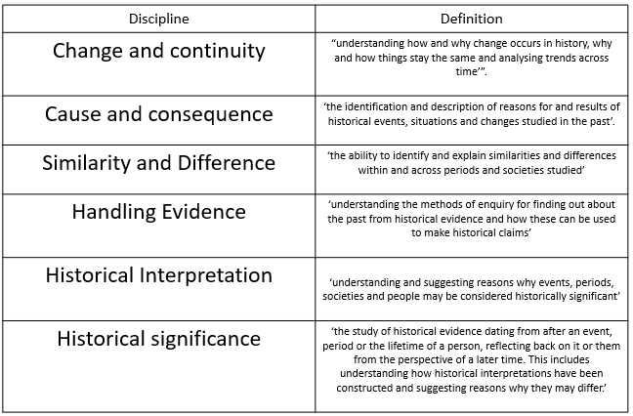
Enquiry should form an important part of the pupil’s work in history. It should take account of pupil’s interests, experiences and capabilities, leading to investigations based on classroom activities and fieldwork. At Broomwood, we ensure that we implement all six disciplines through enquiry-based questions which are the starting point for every history lesson.
Pupils should develop their skills through the National Curriculum breadth of study and Early Years Framework. Key skills should be taught each year, building on previous learning.

A variety of teaching methods will be used best suited to the abilities and interests of the children, including:
- fieldwork and local studies
- observation and enquiry
- individual, group and class investigations
- discussion and debate
- presentation by the teacher

Information will be selected from a variety of sources such as:
- Fieldwork, visits to museums and historical sites
- Visitors
- Photographs, TV and radio programmes and videos
- Documents
- Computer based materials
- Books
- Websites

Some of these resources will be available in the topic boxes in the central resource area for History (in the PPA room). Teachers should also take into account the resource opportunity of the local area and the local community when they plan their work.

Assessment, Reporting and Recording

Formative and summative assessment is carried out in History. At the start of a new History based topic, teachers will carry out a ‘Flash Back Four’. The questions include:
- What is History?
- What History have you previously learnt about? (last term, last year)
- When in History did they happen? (consolidating chronological knowledge)
- What can you remember about what you have learnt? (consider the previous substantive knowledge, consider the golden threads)
Teachers within lessons capture understanding through questioning, discussion, role play and learning activities completed in topic books.

Children complete end of topic assessments which take into account key substantive knowledge and disciplinary concepts. Teachers use Kahoot to make the assessments more engaging and accessible and address key misconceptions in a more timely fashion before moving on to a new topic area. These assessments along with ongoing teacher assessment will allow a judgement to be made by the teacher on Target Tracker. Judgements will range from working towards the expected standard, working at the expected standard, and working above the expected standard.

The Role of the Coordinator
The Coordinator should:
- Be available for advice and consultation to other members of staff
- Be aware of the latest information on curriculum updating and statutory guidelines, and attend courses in order to disseminate this information
- Be responsible for the formulation and updating of a History Policy
- Encourage staff to provide evidence of good practice in classroom teaching
- Initiate liaison with secondary schools where applicable
- To provide guidance and support to staff implementing the curriculum
- To organise, review, purchase and maintain an inventory of resources.
- To ensure staff are aware of current developments in the teaching of History, and the courses available.
- To ensure continuity and progression throughout the school.
- Monitoring the teaching and learning of history throughout the school. This includes: speaking to children and looking at topic books and planning to ensure that the appropriate substantive knowledge is being taught. It also includes carrying out learning walks when instructed by the headteacher. This should take place during subject leadership time.
- Analyse the end of year data and use this to help to triangulate the understanding of how well History is being both taught and the learning that is taking place.
- Create an action plan which addresses any issues that hard or soft data is highlighting and ensure that the link governor is informed of this.
- To be knowledgeable about what happens within every key stage with regards to history and be able to articulate the teaching and learning of history as part of a ‘deep dive’.

The role of the Key stage Leader

- To ensure that planning for history is completed on time and that the key stage teaches all of the necessary substantive knowledge.
- To ensure that books are presented well and that adaptive teaching has been considered
- To ensure that the children within the key stage get a balanced curriculum and the groups of children do not miss out on history due to specific interventions.

The Role of the Head Teacher
The Head Teacher should:
- Support the work of the co-ordinator to enable the school to have a well-planned and well-delivered history curriculum.

Health and Safety
The staff will work in accordance with Trafford’s Health and Safety Guidelines. All visits will be organised in line with the School’s Visits Policy.

Review of policy
This policy will be reviewed and revised in line with developments in the National Curriculum, EYFS and the School Development Plan.

Date reviewed: April 24
Next review date: April 26

