
Broomwood Primary School
Personal Development Plan Overview
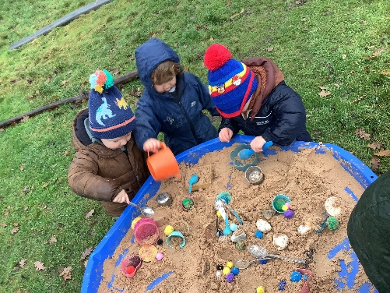
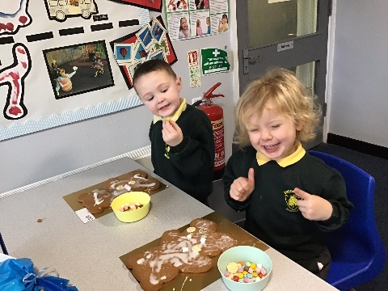
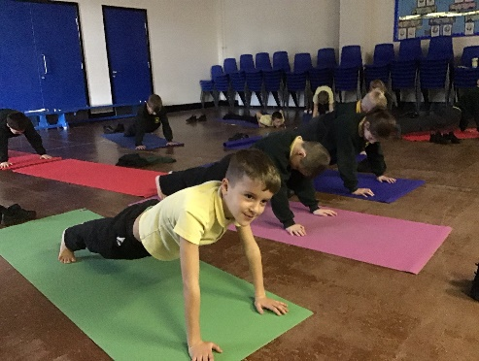
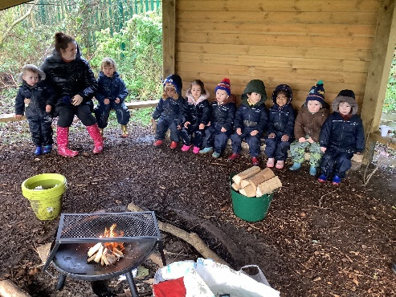
Together we believe. Together we achieve

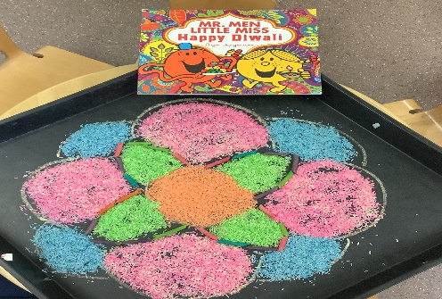
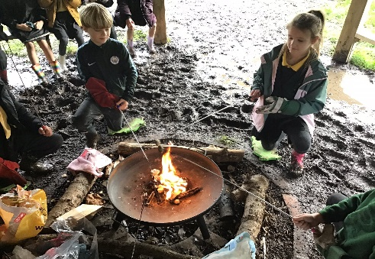
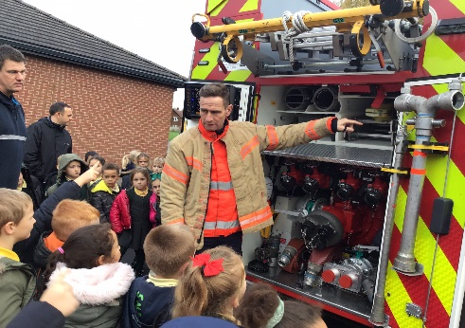
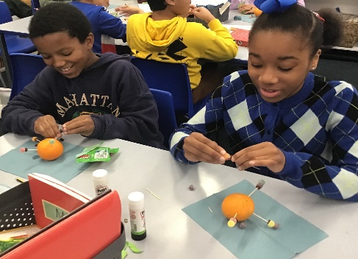

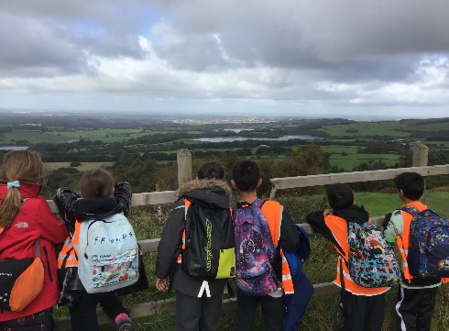
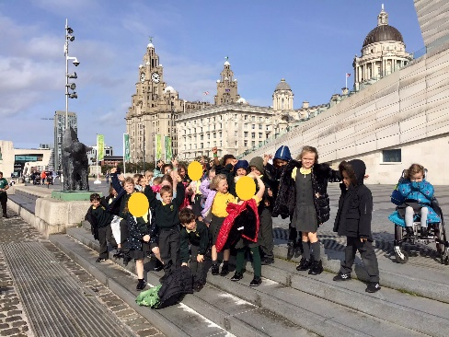
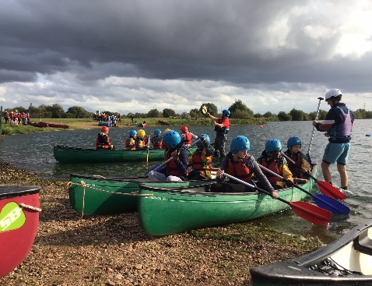
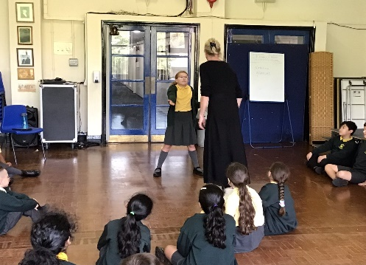

Our school motto is ‘Together we believe. Together we achieve’. This is supported by our whole school values of: Nurturing, Welcoming, Togetherness, Commitment and Respect which underpin everything that we do at Broomwood. At Broomwood Primary, our Personal Development Plan reflects the schools values and it supports in teaching the skills, knowledge and understanding that children need to live confident and healthy lives. In addition, through it, we want the children to become informed, active and responsible citizens.
Through PSHE and RSE, children learn about the emotional, social and physical aspects of growing up. In addition children are taught about relationships and sex education. Within these subjects we aim to promote self-esteem and emotional health and wellbeing to encourage the children to be in a position where they can form healthy and meaningful relationships based on respect for themselves and others. Within a number of subjects across the curriculum the children are also taught how to stay safe and what to do when they don’t.
British Values and Spiritual, Moral, Social and Cultural (SMSC) development are carefully woven throughout the Personal Development curriculum. This enables our children to become successful learners, confident individuals, responsible citizens and effective contributors.

Tier 1
The Curriculum
Whilst personal development is taught throughout all subjects, there are some key subjects where it is more prevalent.
PSHE | At Broomwood we use a thematic approach, with each year group’s objectives divided into the three key themes of Health and Wellbeing: Keeping Safe, Growing and Changing and Healthy Lifestyles; Living in the Wider World: Rights and Responsibilities, Environment and Money and Relationships: Feelings and Emotions, Healthy Relationships, Valuing Difference and Online Relationships therefore this repetition of core themes enables our children to have mastery in these key areas.
RSE | Our bespoke Growing and Changing Curriculum design, within Upper Key Stage Two, fulfils the statutory requirements whilst offering our children a scientifically accurate view of reproduction which is appropriate for their age and maturity. Each year we invite parents and carers to a workshop so that we can share with them the knowledge that the children will learn in order for them to support their child to make sense of this learning at home.
RE | Our Curriculum for RE is designed to follow the agreed syllabus as advised by the Standing Advisory Council on Religious Education (SACRE) within the Local Education Authority for Trafford. As a compulsory part of the curriculum, RE at Broomwood Primary covers a broad range of religions and worldviews in which children encounter living faiths and traditions. In adopting this syllabus we recognise our school community as vibrant and unique with much diversity of religion and beliefs.
Computing | Computing is taught within the school following Kapow as a scheme. E-safety is a significant part of the teaching and supporting children how to be safe and responsible online. Children are reminded of keeping safe online through assemblies and PSHE.  Within the school we ensure that we have an appropriate filtering system and we monitor, using Smoothwall, what children are accessing or writing in order that we can support in keeping them safe.  We regularly write to parents about reminders of how to keep children safe online and get them involved when there have been issues that have occurred outside of school.
Science | Within science we teach children about the reproduction and compliment the work in RSE. We ensure that the children are taught the statutory elements of how to keep themselves healthy through a balanced diet and physical exercise.
Tier 2
Whole School initiatives
Cultural capital/enrichment | We want all pupils within our school to be given opportunities that enhance their learning; their curiosity about learning and to have a greater knowledge of the world around them. We acknowledge that a large number of our pupils are eligible for pupil premium and therefore life opportunities and experiences may be more limited. Within our curriculum, we prioritise enhancements.  - Musical theatre  - Whole school pantomime  - Forest School  - A term of learning a musical instrument  - Trips that are purely just for personal development opportunities but other trips and visitors that contribute to personal development and overall learning  - Gingerbread decorating  - We offer a great range of extra-curricular activities for pupils within the school throughout the year. Most of the clubs are free so that they accessible to all. We ensure that there is a range linked with all subjects to gain the interest of all pupils.
Community | We want our children to become good citizens and recognise the impact that they can have in their own community. To promote this, we  - Have our school choir represent the school at different events in the local community- e.g Christmas singing within Altrincham and at Tesco’s  - We hold vents throughout the year for the over 60’s within our community. The children play a huge role in the entertainment and hosting where they are learning more about the older generation and being respect beyond their own peer group.
Mental health and wellbeing | To support the mental health and wellbeing of all pupils within Broomwood, we have developed a graduated approach. This ensures that this is considered as part of first quality teaching and extends to specific individual interventions. We support children with:  - Teachers carry out a Leuven scale every term, which enables us to identify children that are causing concern.  - Children are able to inform teachers or staff through a wellbeing scale and a worry monster or worry box when they have concerns  - At the start of the year we look at ‘helping hands’. This helps the children to identify trusted adults within school that they can speak to.  - We have reset areas within each classroom and in the playground  - Children have access to yoga which provides them with a way of grounding, reflecting and calming.  - Mindfulness activities are used within the school week
Physical wellbeing | In addition to the curriculum PE allocate time, we promote physical activity within the school and enable the children to understand how to keep healthy. We develop this further with:  - The use of 5 a day within the classroom  - We have an annual PE week where new sports are promoted with the children  - We encourage children to access different games and activities at playtime and lunch time  - We promote healthy lunch boxes in school  - We enhance the cookery curriculum so that children within year 3 learn more about food so that they can go on to make better choices.  - We are trying to support children’s Physical wellbeing by holding cookery classes for parents to support them in making better choices for their children by developing their cooking skills.
Keeping safe | We recognise that we have responsibility of teaching the children how to stay safe. In addition to the curriculum offer within PSHE and computing, we promote this through:  - Children understanding that we have a safeguarding team within the school- they learn this through assemblies and they have an understanding of what this team does to help keep children safe.  - We explore the PANTs rule across the school so that the children understand about appropriate touch  - We have a child on child abuse policy that has been explained to the children so that the understanding of touch is developed further  - Inviting people like the police and fire brigade to come and speak to the children  - We promote anti-bulling in school with a specific day which we highlight what bullying is and what can be done about it
Assemblies and Celebrations | Throughout the year, we develop the spiritual and moral aspects of SMSC through assemblies and whole school celebrations.  - Each assembly is based on a theme across the year and christen and other faith assemblies are linked to the theme. Quotes linked to the theme are considered within class for children to reflect on them. Assemblies also look at world events.  - Father Steve from the local parish comes in to deliver assemblies and support within RE lessons. Children and parents of other faiths are asked to also support in assemblies and within RE lessons.  - Across the year, as a whole school we celebrate key festivals. We compete learning activities linked to Christmas (Christingle), Chinese/Lunar New Year, Holi etc…  - To further develop links with parents, we hold key events within the school- Pumpkin Fest, Winter Wonderland
Raising Aspirations and preparing for the future | We want to make sure that children are ready for key transitions throughout their educational journey and we also want pupils to have aspirations of what they want to be and work towards. We try to raise aspirations by:  - We have a PE week- within this we look at key role models and their achievements  - We have a STEM week- within this, we invite parents in to speak to children and consider what jobs children could have in the future  - We have a history/Geography week- again to consider what job opportunuities are available as well as developing more interest in these subjects  - We have links with key high schools where they have opportunities to go and visit and explore particular subjects at a higher level.
Tier 3
Year Groups and Individuals
EYFS | - Stretch & Grow  - Forest School  - Nativity  - Farm  - Bug visitor  - Elsa Party  - Ugly Bug Ball
KS1 | - Nativity  - Forest School  - Liverpool Toy Museum  - Fire engine visit  - Police visit  - Seaside trip  - Panto  - Zoo  - Local Woods  - Library Visits
LWKS2 | - Cooking  - Gardening  - Boxing  - Swimming  - Panto  - Church Christmas  - Chester Roman Experience  - Stone Age Visitor  - Library Visits
UPKS2 | - Y6 residential  - Y5 climb a mountain  - Panto  - River Trip  - Church Christmas  - Manchester Trip  - African drummers  - Library Visits
Individuals | As an inclusive school, we recognise that a number of individuals within our school require further support within their personal development:  - We pay for 1-1 peripatetic music lessons  - We have a nurture group every morning  - We provide targeted supported over break and lunch times  - Our graduated approach to mental health and wellbeing, provides key support for those individuals who require it.

Together we believe. Together we achieve
SMSC
Spiritual, Moral, Social and Cultural

Spiritual  We are committed to:  - Celebrating the religious and non-religious beliefs and values that our pupils bring as part of their family culture/heritage and to build an awareness of and respect for others’ spiritual and religious beliefs  - Fostering common human values and building spiritual capacities to promote self-worth, self-esteem and a valuing of others  - Helping our pupils to come to an understanding of themselves as unique individuals  - Developing our pupils’ curiosity, imagination, creativity and promoting a sense of awe and wonder. | Spiritual  We promote this through:  - Our assemblies and Quotes of the week/collective worship  - Celebration assemblies  - Whole school celebration of festivals  - Christmas performances  - School visits to places of worship and visitors to school  - Educational visits and visitors which inspire awe and wonder  - Themed days and weeks  - RE curriculum  - PSHE curriculum
Moral  We are committed to:  - Be truthful and honest  - Respect the rights and property of others, their opinions and customs, even when they are different from our own  - Help others  - Solve differences of opinion  - Consequently, we reject all forms of bullying, cruelty, dishonesty, violence and discrimination and have procedures in place for dealing with such instances. | Moral  We promote this through:  - The relational inclusion policy and how we support the children in repairing when they have done something wrong  - School, values  - The promotion of British values  - Support charities and fund raising  - PSHE curriculum  - Collective worship
Social  We are committed to:  - Fostering the skill and qualities of team building through the development of self-confidence, co-operation, sensitivity to others, reliability, initiative and understanding  - Providing an environment where pupils can take responsibility for themselves and others in school and the wider society  - Acceptance and engagement with the fundamental British values of democracy, the rule of law, individual liberty and mutual respect and tolerance of those with different faiths and beliefs.  - Enabling pupils to develop and demonstrate skills and attitudes that will allow them to participate fully in and contribute positively to life in modern Britain | Social  We promote this through:  - The whole school values  - The use of collaborative working when learning  - The class charter  - How children are supported at break time and lunch time through games they play together  - Extra-curricular activities  - School ambassadors  - Eco warriors  - PE week  - Sports Day  - STEM week  - Forest school
Cultural  We are committed to:  - Promoting an appreciation of our own cultural tradition/s and encouraging an appreciation of other peoples’ cultural traditions  - Celebrating the richness of culture and tradition  - Providing opportunities for pupils to participate in and respond positively to artistic, musical, sporting and cultural opportunities | Cultural  We promote this through:  - Musical theatre  - School pantomime visit  - KS1 visit to the Bridgwater hall- live music  - Key topics in school- Amazing Africa, Investigating India, The British Empire, Greeks  - Celebrating key festivals  - Music and art curriculum  - African drummers visit  - Different songs within singing assembly  - All children from year 1-year 6 learn an instrument  - Religion and Empire are golden threads within our history curriculum

Together we believe. Together we achieve
The British Values

Democracy  We teach that this means that the people in Britain vote for the people who make the laws and decide how the country is run. If we didn’t have a democracy, just one person might be able to make all the laws and that would not be fair. | At Broomwood we promote this:  - By teaching the Greeks within year 5 and 6, democracy is explored and understood at a higher level  - Voting for things within school- marble treats, the school ambassador  - Giving the children a chance to express their opinion in how to make changes within the school
Individual Liberty  In Britain, as long as we do not break the law, we can live as we choose to and have our own opinions about things. | At Broomwood Primary School we allow children to express themselves in their own way and treat everyone as an individual. Some children might choose to express themselves through the clothes that they wear or their hair cut, or through the activities that they like to engage in such as football, swimming, boxing, reading, musical theatre, computing. All children are given equal access to these things.  We accept differences and respect them.
Rule of Law  In Britain we have a police force and a criminal justice system who make sure people do not do the wrong thing and break the law – this means that we are safe. | At Broomwood Primary School we have our core values which underpin our behaviour curriculum. These are like our rules/laws and they are there to keep us safe and happy. If you ‘break’ a core value, there is usually a consequence whereby you do some work with a senior leader to help you learn for next time and repair any damage.
Mutual Respect  We might not always agree with other people, but we try to show respect for their thoughts and feelings.  We can give respect to others and we can expect other people to show us respect. | At Broomwood Primary, Respect is one of our core values and so comes into every aspect of the school day.  - Respecting others in the classroom, the playground and the lunch hall.  - We show respect in what we say, do and how we respond to people  - We continue the value of respect outside of school too.
Tolerance of other faiths and beliefs  In Britain we accept that other people might have different beliefs than ours and they may believe in different religions. | At Broomwood Primary School we teach RE and learn about different religions, what the different beliefs are and how their daily lives may be as a result of these beliefs.  - We learn about different festivals in assemblies.  - We celebrate different festivals as a school such as Christmas, Chinese New Year, Holi.  - We have a very diverse school community with children who are Christian, Muslim, Sikh and Hindu as well as children who don’t follow a religion. We respect all faiths and beliefs.

