Healthier Food Swaps
When packing your lunch box, make some healthier choices by staying away from foods which are high in fat, sugar and salt.
Please Do NOT include any chocolate or chocolate-based deserts, cereal bars, nuts or fizzy drinks.
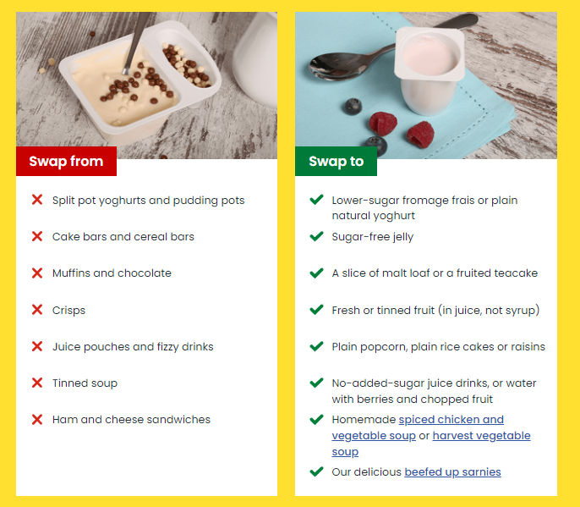
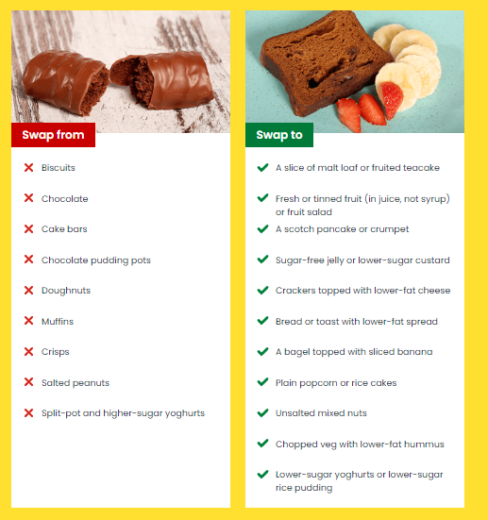
There are plenty of suggestions below for you to choose from along with many more ideas on https://www.nhs.uk/healthier-families/recipes/healthier-lunchboxes/#swaps . In order to keep in line with the balanced diet offered to those on school dinners we will allow fruit/oat-based biscuits (no chocolate) and cake with icing as a treat. Crisps will also be allowed but please encourage your child to make healthy choices from the lists below and where possible buy reduced sugar foods.

